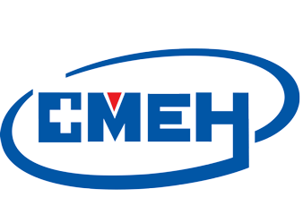
2024深圳国际医疗器械展览会

Shenzhen International Medical Devices Exhibition 2024

邀请函Invitation letter

2024深圳国际医疗器械展览会，将于2024年12月18-20日在深圳召开。是中国的医疗器械展之一。为促进交流，加强合作，我们主办方上海聚亿展览服务有限公司特邀请贵公司参加此次展览，敬请光临。

Shenzhen International Medical Devices Exhibition 2024 will be held in Shenzhen during 18th - 20th December 2024. The Exhibition is the largest and most influential exhibition. It’s the Medical industry event in the world, and also China’s largest exhibition of medical equipment. In order to well communicate & have a good cooperation in the future, we sincerely invite you to take part in the exhibition at time.

展览时间：2024年12月18-20日 展览地点：深圳国际会展中心

Date：: 18th - 20th December 2024 Venue: Shenzhen World Exhibition & Convention Center
被邀请人员名单Invitees name list
外文姓名  English Name | 性别  Gender | 出生日期  Date of birth | 国籍  Nationality | Date of Issue  Expiry date | 护照号码  Passport number | Place of issue

被邀请人员其他信息Other information of the Invitees
来访目的（中文）Purpose of the visit(Chinese): | 参加展会Attend medical exhibition
访问地点Place to visit: | 深圳 Shenzhen
签证类型Visa type:
签证有效期Visa is valid:
签证有效期次数The times of visa valid：
每次停留days you stay every time：
签证申请地点Location of the visa application:
拟入境日期Intended date of entry:

工作单位 Company name:

联系电话 contact no.:

传真 fax no.:

联系地址 address:

组委会：上海聚亿展览服务有限公司
Shanghai Juyi Exhibition Service Co.,Ltd
Organizers(Official Seal):

Person in Charge (Signature):

Date (D/M/Y):

Tel: +86-21-31078231

Fax: +86-21-64126798
E-mail: sales_bjlzhb@163.com
http://www.med-exhibition.com
Contact Person: Mr Lin Hao
cellular phone:+86-15902186639

